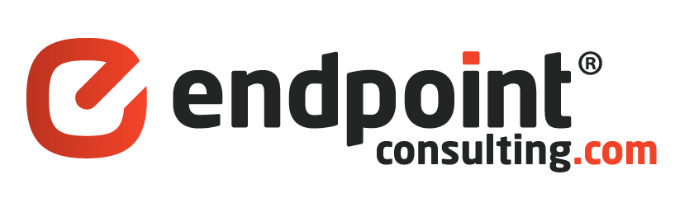Case Study

IT and Database Consulting for Marketing G2: A decade long technical partnership

Executive Summary

For almost 10 years EndPointConsulting has been working with Marketing G2 to design, deploy and manage large-scale database marketing systems for some of the largest newspaper brands in the country.

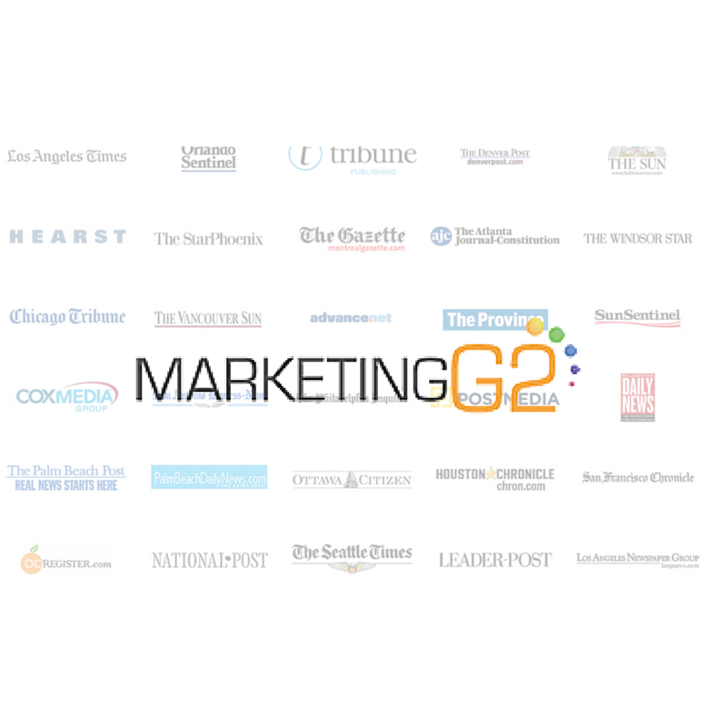

Technologies involved:

* Microsoft SQL Server
* Microsoft .NET Framework
* HTML5
* ANGULARJS
* NODE.JS
* Web API

Challenges

MarketingG2 (MG2) was a startup organization that was founded by Patrick Glennon. MG2 originally attempted off-shoring development on its own. They were very unhappy with the initial performance when going it alone and engaged the services of EndPointConsulting (EPC). What started off as simple database and administrative services quickly expanded after EPC proved themselves and became MG2’s entire IT and database team.

From there the relationship has grown and the EPC team that now serves MG2 has grown from just 2 people to 9 full time consultants. EPC has been instrumental in building out the MG2 technology stack. Products developed and launched include:

Insert Quote

* Open Intelligence
* Solicitor Concierge
* Mobile Concierge
* Subscriber Concierge
* Touchpoint

How Services Helped

EPC provided the necessary offshore database and IT talent to help MG2 grow cost effectively and maximize value to their clients. EPC has consistently delivered quality products on time and under budget. The services they provided were at a fraction of the cost of onshore local talent.

Results, Return on Investment and Future Plans

Currently EPC has expanded their MG2 partnership by adding a team of QA engineers as well as a web development team. The team now serving MG2’s needs has now grown to 15 people across 2 different offices in Belarus.